Comprehensive Analysis of the Gansu Vision Intervention Project

1. Introduction and Development Significance
The Gansu Vision Intervention Project (GVIP) represents a landmark randomized controlled trial (RCT) addressing a critical gap in development economics and public health: the link between vision health and human capital accumulation. While approximately 10% of primary school students in developing countries suffer from poor vision, the vast majority possess no corrective eyewear.
Conducted in Western China, this trial is distinct because it moves beyond simple enrollment metrics to measure actual learning outcomes. The study reports that for the preferred "compliant" sample, the intervention yielded statistically robust and educationally significant results:
- Intent-to-Treat (ITT): The offer of free glasses increased test scores by 0.11 to 0.16 standard deviations.
- Average Treatment Effect on the Treated (ATT): Actually wearing eyeglasses for one academic year increased average test scores by 0.16 to 0.22 standard deviations.
- Educational Equivalence: These gains are equivalent to 0.3 to 0.5 additional years of schooling.
Crucially, the GVIP demonstrates that correcting vision is not merely a health intervention but a high-return educational investment, yielding higher returns than many supply-side interventions (such as improving school facilities).

2. Novelty in Intervention Delivery: The "Uptake" Challenge
Unlike clinical trials where the primary challenge is often biological efficacy, the GVIP highlighted that the effectiveness of health technology in developing contexts is heavily constrained by adoption behavior.

2.1 The "Refusal" Phenomenon
Despite the eyeglasses being offered entirely free of cost (a value of 120 Yuan, or ~$15 USD), the trial encountered a significant "uptake gap."
- Refusal Rate: Approximately 30% of students (or their parents) who were screened with poor vision and offered glasses refused to accept them.
- Gender Disparity: Girls were significantly less likely to accept glasses than boys (66.0% vs 73.6%), a finding potentially linked to concerns about appearance, though stated reasons were similar across genders.
- Authority Skepticism: Surprisingly, children of village cadres and schoolteachers were less likely to accept the glasses (33.6 percentage points lower for cadres), suggesting skepticism among local elites.

2.2 Information Failures
The trial revealed that a lack of demand is driven by information asymmetry.
- Parental Unawareness: In the associated survey data, 82% of mothers whose children had "fair" vision and 62% of those with "poor" vision incorrectly believed their child's vision was "good" or "very good".
- The "Deterioration" Myth: A prevalent cultural belief in the region is that wearing glasses will cause a child's vision to deteriorate faster, acting as a major barrier to uptake.

3. Addressing Methodological Issues: Randomization, Departures, and Integrity
The integrity of the GVIP analysis rests on its rigorous handling of protocol deviations. The study was designed as a cluster-randomized trial involving 37 townships (19 treatment, 18 control). However, the execution faced "contamination" driven by local political dynamics.

3.1 Protocol Non-Adherence
In 6 of the 37 townships, the randomization protocol was compromised:
- Contamination of Control: In five control townships, local officials used surplus funds to purchase glasses for students in the control group.
- Role Reversal: In one pair, the treatment township received no offers, while the control township did.

3.2 The "Compliant Sample" Correction
To preserve internal validity, the investigators separated the analysis into two distinct sets. The validity of the final conclusions depends on the "Compliant Sample."
Analysis Set | Methodology | Consequence for Validity
Full Sample (37 Townships) | Includes contaminated control groups who received treatment. | Biased Downward. Because the control group improved (received glasses), the difference between Treatment and Control is artificially shrunk. Estimates using this sample underestimate the true effect.
Compliant Sample (25 Townships) | Excludes township pairs where protocol was violated. | Preferred Estimate. Restores the validity of the counterfactual. Robustness checks (Table 3) confirmed that excluding non-compliant townships did not introduce selection bias or demographic imbalances.

4. Statistical Rigor: Clustering and Small Sample Corrections
The trial utilized advanced econometric techniques to correct for the specific structure of the data: clustering at the township level and school-specific testing variations.

4.1 Correcting for "Small Cluster" Bias
Standard errors in cluster-randomized trials can be misleading when the number of clusters is small (<30). The compliant sample contained only 25 townships.
- The Flaw: Standard clustering formulas might overstate statistical significance.
- The Solution (Wild Bootstrap): The authors employed the Wild Bootstrap method. This resampling technique provides accurate p-values even with few clusters.
- Result: Even under this rigorous stress test, the impact on test scores in County 1 remained statistically significant (p-value 0.026).

4.2 Instrumental Variable (IV) Analysis
To solve the problem of partial uptake (30% refusal), the study used Instrumental Variable estimation.
- Instrument: The random assignment ($P_s$, offer of glasses).
- Endogenous Variable: Actual wearing of glasses ($G_{is}$).
- Outcome: Since the randomization is valid, it serves as a perfect instrument to measure the impact of wearing glasses, stripping away the selection bias of who chose to accept them.

5. Results and Heterogeneity: The County Disparity
A definitive feature of the GVIP is the heterogeneity of the results. While the pooled effect was positive, a deep dive reveals a stark contrast between the two study counties.

5.1 The "Vitamin A" Hypothesis
- County 1: Showed massive gains (0.39 SD intent-to-treat effect).
- County 2: Showed statistically insignificant results.
The authors attribute this to nutritional health, specifically Vitamin A Deficiency (VAD).
- Evidence: County 1 students had significantly higher hemoglobin levels and height-for-age Z-scores than County 2, indicating better nutrition.
- Mechanism: VAD causes night blindness. Eyeglasses correct refractive errors (myopia) but cannot fix night blindness. In dim lighting (common in rural homes), students with VAD cannot study effectively even with glasses.
- Conclusion: This suggests a biological interaction: vision correction requires a baseline of nutritional health to be effective educationally.

5.2 The "Catch-Up" Effect
The trial found that the benefits were not evenly distributed by ability.
- Below Average Students: Gained 0.27 SD.
- Average Students: Gained 0.11 SD.
- Above Average Students: Saw no significant gain.
This indicates that poor vision acts as a "ceiling" for lower-performing students. Removing this barrier allows for rapid academic catch-up, promoting educational equity.

6. Risk of Bias Assessment (Adapted Cochrane Tool)
Based on the documented procedural deviations, the GVIP's risk profile is summarized below:
Domain | Risk Assessment | Justification
1. Bias arising from the randomization process | High Risk (Mitigated) | Implementation failed in 6 of 18 pairs due to local official interference. However, the "Compliant Sample" analysis successfully mitigated this by excluding contaminated clusters.
2. Bias due to deviations from intended interventions | High Risk | Significant contamination occurred where control groups received glasses. This necessitated the exclusion of nearly a third of the sample to preserve validity.
3. Bias due to missing outcome data | Low Risk | Test scores were collected from administrative school records for all students, regardless of whether they accepted the glasses, preserving the Intention-to-Treat principle.
4. Bias in measurement of the outcome | Low Risk | Outcomes were standardized academic tests. While schools used different exams, scores were normalized, and randomization ensured no systematic bias across arms.
5. Bias in selection of the reported result | Low Risk | The authors transparently reported results for both the "Full" (biased) and "Compliant" (clean) samples, allowing for full scrutiny of the protocol deviations.

7. Cost-Benefit Analysis and Economic Return
The economic argument for the intervention is overwhelming when viewing the long-term labor market returns.
- Cost of Intervention: ~120 Yuan ($15 USD) per pair of glasses.
- Educational Gain: Equivalent to 0.33 to 0.5 additional years of schooling.
- Wage Premium: One year of schooling in rural China increases wages by ~9.3%.
- Return on Investment: The Present Discounted Value (PDV) of the future wage increase is estimated at 1,834 Yuan (at a 5% discount rate). This exceeds the cost of the glasses by a factor of 15.

8. Conclusion
The Gansu Vision Intervention Project provides compelling evidence that uncorrected vision is a primary, yet easily solvable, constraint on human capital in developing countries. While the trial faced significant implementation challenges—specifically the contamination of control groups by well-meaning local officials—the rigorous statistical re-analysis confirmed robust positive effects.
The study highlights two critical lessons for future development policy:
- Synergies matter: Health interventions (glasses) may be ineffective if underlying conditions (Vitamin A deficiency) are not addressed.
- Information is key: The major barrier to adoption was not cost (glasses were free) but the lack of parental awareness and persistent myths about eye health.

Experimental Design: Cluster Randomization and Stratification
The GVIP was designed not as a simple randomized controlled trial (RCT), but as a Cluster-Randomized Trial (CRT). This design choice was necessitated by the logistical reality of rural education systems, where interventions are best delivered at administrative levels rather than individual levels.

1.1 The Unit of Randomization
The unit of randomization was the Township, not the school or the student.
- Total Sample: 37 Townships across two counties.
- Rationale: Randomizing at the township level minimizes spillover effects (contamination) that might occur if students in the same school or neighboring villages were assigned to different conditions.

1.2 Stratification Strategy
To increase statistical power and ensure baseline balance, the investigators employed a Pairwise Stratification method based on economic indicators.
- Townships were ranked by per capita income (2003 data).
- Townships were paired (e.g., the two wealthiest, the next two, etc.).
- Within each pair, one township was randomly assigned to Treatment and the other to Control.
This stratification reduces the variance of the estimator by ensuring that treatment and control groups are matched on observable economic characteristics prior to the intervention.

2. The Integrity Challenge: Protocol Deviations
A critical aspect of the GVIP's statistical narrative is the handling of "non-compliance" at the cluster level. In a laboratory setting, randomization is absolute. In the field, it is vulnerable to human behavior.

2.1 The Contamination of the Control
Post-trial auditing revealed that the randomization protocol was violated in 6 out of 18 township pairs.
- The Mechanism of Failure: Local officials, having successfully distributed glasses to the treatment group, utilized surplus funds to purchase glasses for students in the control group.
- Statistical Consequence: This creates a violation of the exclusion restriction for the control group. If the control group receives the treatment, the Intent-to-Treat (ITT) estimate (Treatment Mean minus Control Mean) biases the result toward zero (attenuation bias).

2.2 The Remediation: The "Compliant Sample"
To recover an unbiased estimate, the authors segregated the data into the "Full Sample" (37 townships) and the "Compliant Sample" (25 townships).
- Selection Bias Check: The primary threat to this exclusion strategy is selection bias. If "compliant" townships differ systematically from "non-compliant" ones, the external validity is compromised.
- Statistical Proof: Balance checks (Table 3 and Appendix Table A.3) utilized regressions with school random effects to demonstrate that there were no statistically significant differences in baseline characteristics (test scores, ethnicity, parental education) between the compliant and non-compliant samples. This validated the decision to discard the contaminated clusters.

3. The Econometric Model
The study employed two primary specifications to isolate the causal impact of the intervention.

3.1 The Double-Difference Model
To increase precision, the analysis did not simply compare students with poor vision in treatment vs. control. It utilized a "Double-Difference" approach, incorporating students with good vision as a within-school control.
The estimation equation was:
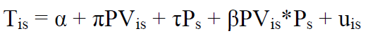
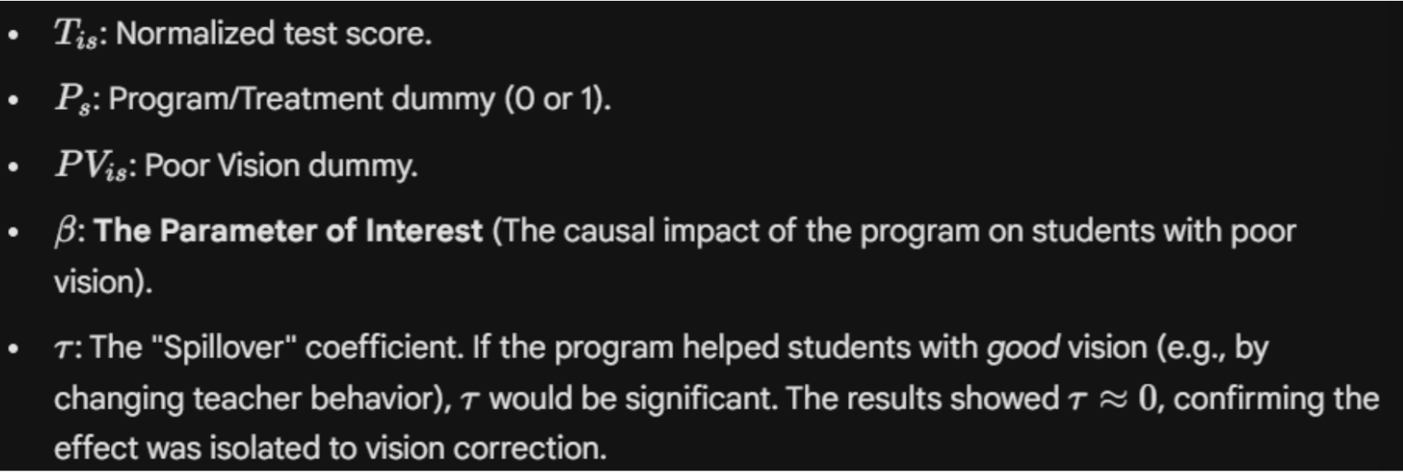

3.2 Standardization of Heterogeneous Metrics
A major statistical hurdle was that primary schools in rural China do not administer a standardized provincial exam; each school designs its own tests.
- The Problem: Raw scores are not comparable across schools (Cluster A's math test might be harder than Cluster B's).
- The Solution: The authors normalized scores into Z-scores within each control group distribution:
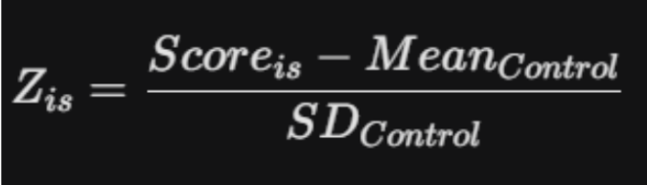
This converts all outcomes into standard deviations, allowing for pooled analysis despite heterogeneous testing instruments.

4. Inference with Small Clusters: The Wild Bootstrap
Perhaps the most sophisticated statistical contribution of the paper is the handling of standard errors.

4.1 The "Small G" Problem
The compliant sample included only 25 clusters (townships).
- Standard econometric theory for clustered standard errors relies on asymptotics where the number of clusters ($G$) approaches infinity.
- When $G < 30$, standard clustered errors can be downward biased, leading to Type I errors (false positives).

4.2 The Solution: Wild Bootstrap
To ensure the significance of the results was real and not an artifact of the small sample size, the authors calculated p-values using the Wild Cluster Bootstrap-t method (Cameron, Gelbach, & Miller, 2008).
- Mechanism: This method resamples the residuals of the clusters to generate a simulated distribution of the t-statistic.
- Outcome: Even under this rigorous stress test, the p-values for County 1 remained significant ($p < 0.05$), providing high confidence that the observed effects were not random noise.

5. From "Intent" to "Action": Instrumental Variables (IV)
The ITT estimates measure the impact of offering glasses. However, roughly 30% of students refused the offer. To measure the physiological impact of wearing glasses (Average Treatment on the Treated), the authors used Two-Stage Least Squares (2SLS).
- First Stage: Predict "Wearing Glasses" ($G_{is}$) using "Random Assignment" ($P_s$).
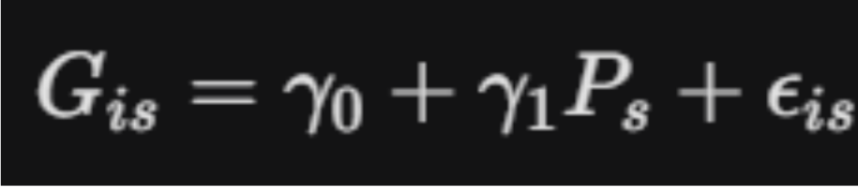
- Second Stage: Regress test scores on the predicted wearing of glasses.
- Validity: Since assignment was randomized, $P_s$ is uncorrelated with the error term $u_{is}$ (satisfying exogeneity) and highly correlated with wearing glasses (satisfying relevance).
- Result: The IV estimates were approximately 1.5 times larger than the ITT estimates, revealing the true biological efficacy of the intervention.

6. Falsification and Robustness
To further "bulletproof" the findings against omitted variable bias, the authors conducted falsification tests.
- Pre-Trend Analysis: They ran the same regression models using data from the year prior to the intervention.
- Hypothesis: If the treatment schools were simply "better" schools on a trajectory of improvement, we should see a positive coefficient $\beta$ even before the glasses were handed out.
- Result: The estimated "effect" for the pre-program year was -0.02 (statistically insignificant). This null result strongly supports the causal claim that the glasses caused the subsequent test score improvements.

7. Summary of Statistical Integrity
The GVIP paper serves as a masterclass in applied econometrics for development. It demonstrates that trial integrity is not merely about preventing protocol failures, but about having the statistical toolkit to recover truth when those failures inevitably occur. Through the use of compliant sub-sampling, Wild Bootstrap inference, and IV estimation, the authors transformed a messy field trial into a rigorous proof of human capital development.

References:
Glewwe, P., Park, A., & Zhao, M. (2016). A Better Vision for Development: Eyeglasses and Academic Performance in Rural Primary Schools in China.
- Authors: Paul Glewwe (University of Minnesota), Albert Park (Hong Kong University of Science and Technology), and Meng Zhao (Gakushuin University).
- Date: May, 2016.

